REAL ESTATE CRM
@CREATIVITY THINK (9483175986/7019689991)

ABSTRACT:
The Real Estate CRM is a web-based platform designed to streamline workflows for real estate agents, brokerages, and sales teams. Users can enter and manage leads, track properties, follow sales pipeline progress, and monitor client communications. Administrators manage teams, oversee property listings, track bookings, and analyze sales performance through dashboards. Built with Django and Django Rest Framework for backend operations and React with Recharts and Chart.js for frontend visualization, the system provides a secure, real-time, and collaborative environment. The platform enhances efficiency, improves lead conversion, and provides actionable insights for real estate sales teams..

INTRODUCTION OF THE PROJECT:
Efficient management of leads, properties, and sales pipelines is critical for real estate businesses. The Real Estate CRM addresses these needs by providing a centralized platform for tracking leads, managing properties, coordinating team activities, and analyzing sales data. Users can input leads, view property details, track bookings, and monitor pipeline progress, while administrators manage teams, oversee dashboards, and generate analytics. Utilizing Django for backend operations and React with Recharts and Chart.js for frontend visualization, the system ensures real-time collaboration, secure data management, and operational efficiency, improving overall performance and decision-making for real estate sales teams..

PROJECT OBJECTIVES:

• Centralize real estate lead and property management
• Enable tracking of client communications and bookings
• Provide real-time sales pipeline monitoring for users
• Allow administrators to manage teams, properties, and bookings
• Generate analytics dashboards for performance insights
• Improve team collaboration and workflow efficiency
• Enhance lead conversion and sales performance

PROBLEM OF THE STATEMENT:
Real estate businesses often rely on fragmented tools for managing leads, properties, and sales pipelines, resulting in delayed communication, inefficiencies, and lost opportunities. Agents and sales teams need a single platform to track leads, manage properties, monitor pipeline stages, and collaborate effectively. Administrators require a dashboard for team management, performance monitoring, and analytics. The Real Estate CRM solves these problems by providing a centralized, web-based system for managing all aspects of real estate sales operations, improving efficiency, collaboration, and decision-making..

MOTIVATION OF THE PROJECT:
• Streamline real estate workflows for agents and teams
• Improve lead management and conversion tracking
• Provide centralized property and booking management
• Enable real-time monitoring of sales pipelines
• Offer analytics dashboards for performance insights

BLOCK DAIGRAM OF PROJECT:

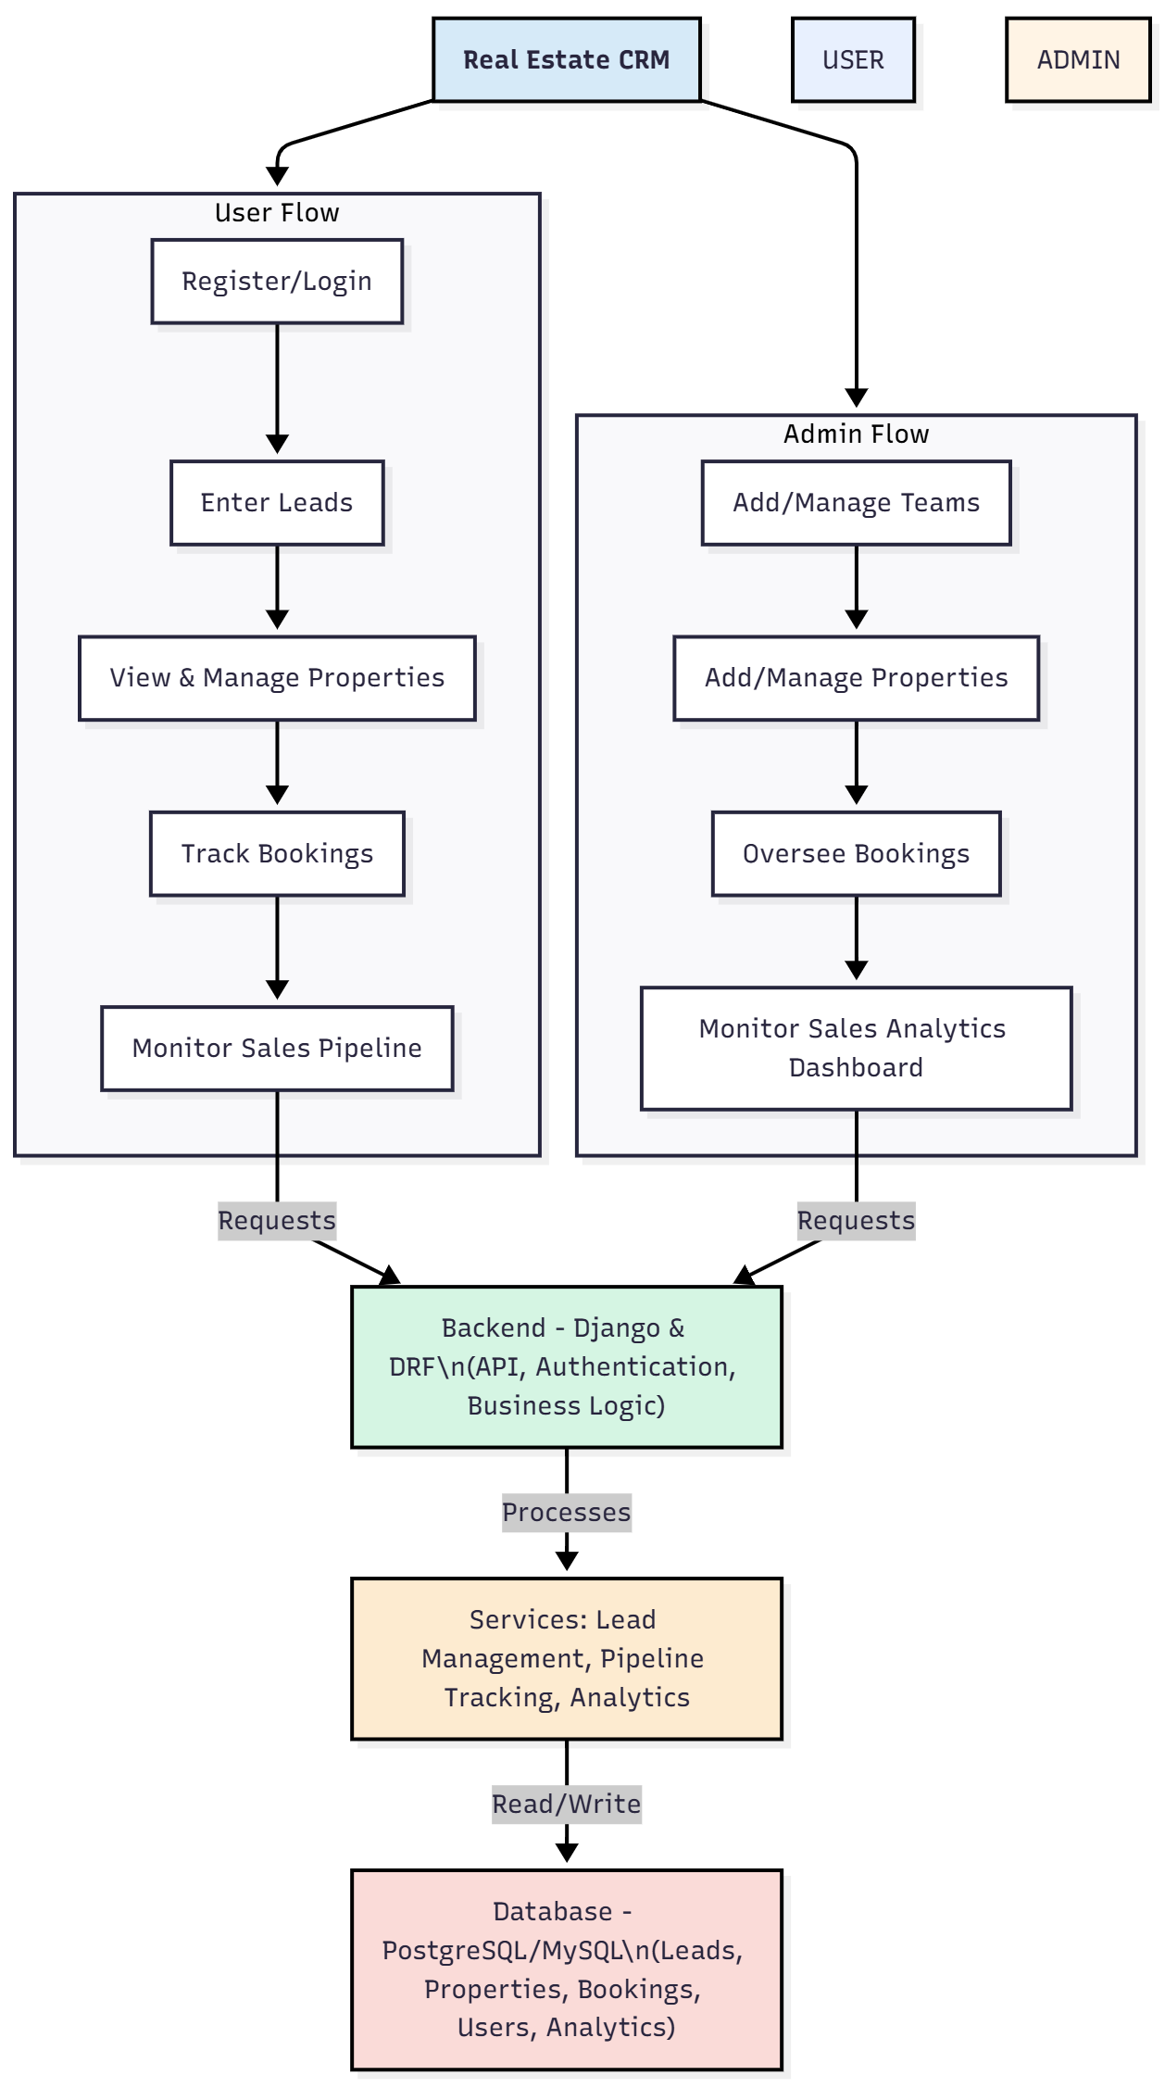

WORKING OF THE PROJECT:
Users register or log in to the Real Estate CRM, enter and manage leads, view property listings, track bookings, and monitor their sales pipeline. The backend handles authentication, API requests, and business logic, while services manage lead tracking, pipeline stages, and analytics dashboards. Administrators can manage teams, edit property and booking information, and monitor overall sales performance via dashboards. The system provides a centralized, real-time environment for both users and administrators, ensuring efficient workflows, improved communication, and enhanced lead conversion..

SOFTWARE REQUIREMENT:
- Backend:
  - Python 3.x
  - Django
  - Django REST Framework
  - SQLite/PostgreSQL
- Frontend:
  - Node.js and npm
  - React.js
  - Axios
- Development Tools:
  - Visual Studio Code
  - Postman (for testing APIs)
  - Git/GitHub (for version control)
- Server/Deployment (Optional):
  - Gunicorn, Nginx, or Heroku/AWS for hosting

ADVANTAGES OF THE PROJECT:

• Centralized management of leads and properties
• Real-time tracking of bookings and sales pipeline
• Analytics dashboards for performance monitoring
• Improved communication and team collaboration
• Secure authentication and data handling
• Efficient management for sales teams and administrators
• Reduces missed opportunities and enhances lead conversion
• Scalable solution for small to large real estate organizations

APPLICATIONS OF THE PROJECT:
• Real estate agencies and brokerages
• Sales team management and coordination
• Property and booking tracking
• Lead and customer relationship management
• Pipeline analytics for sales performance
• Team activity monitoring and reporting
• Property marketing and client communications
• Enterprise-level real estate CRM solutions

REFERENCES:

- Django REST Framework Documentation — Django Software Foundation. Django Documentation. Available: https://docs.djangoproject.com/
- Django REST Framework. DRF Documentation. Available: https://www.django-rest-framework.org/
- React. React Official Documentation. Available: https://reactjs.org/docs/getting-started.html
- Redux. Redux Documentation. Available: https://redux.js.org/introduction/getting-started
- PostgreSQL Global Development Group. PostgreSQL Documentation. Available: https://www.postgresql.org/docs/
- MySQL. MySQL Reference Manual. Available: https://dev.mysql.com/doc/
- Git. Git Documentation. Available: https://git-scm.com/doc
- Node.js. Node.js Documentation. Available: https://nodejs.org/en/docs/
- Axios. Axios Documentation. Available: https://axios-http.com/docs/intro
- Socket.io Documentation – https://socket.io/docs/

